Session7

Assignment2

1. Write a program to create barplots for all the categorical columns in mtcars.

Solution:

mtcars

str(mtcars)

# change the categorical variables to factor

library(dplyr)

mtcars1 <- mutate(mtcars,

cyl = as.factor(cyl),

disp = as.factor(disp),

vs = as.factor(vs),

am = as.factor(am),

gear = as.factor(gear),

carb = as.factor(carb))

str(mtcars1)

is.fact <- sapply(mtcars1, is.factor) # checking the categorical variables

mtcars2 <- mtcars1[,is.fact] # creating dataframe of only factor class of variables

str(mtcars2) # check structure

par(mfrow= c(2,3)) # Set plot area

lapply(lapply(mtcars2[,1:5], table), barplot) # barplots for categorical var

2. Create a scatterplot matrix by gear types in mtcars dataset.

Solution:

attach(mtcars)

library(car)

pairs(~mpg+disp+drat+wt|gear,data=mtcars, main="Simple Scatterplot Matrix")

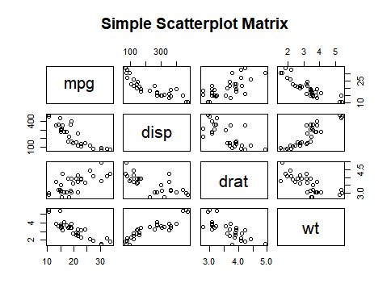

3. Write a program to create a plot density by class variable.

Solution:

par(mfrow = c(1,1))

x <- mtcars$mpg # assign mpg to a object

h <- hist(x, breaks = 10, col = "red", xlab = "MPG", main = "Density plot of mpg") # plot histogram of the object

xfit <- seq(min(x), max(x), length = 40) # create 40 points on x axis

yfit <- dnorm(xfit, mean = mean(x), sd= sd(x)) # normal plot of xfit

yfit <- yfit*diff(h$mids[1:2]*length(x)) # mids of the histogram with changing x

lines(xfit, yfit, col="Blue", lwd = 3) # line plot for xfit and yfit